**WEB-BASED INTERFACE DESIGN**

**(CSF3133)**

**LAB REPORT 8**

Name: Syazwani Binti Salim

Matric.no: S75782

Group: k4

Programme: Bachelor of computer Science (Software Engineering)

Lecturer’s name: Dr. Wan Nural Jawahir

Lab Administrator’s name: Madam Fatin Fatihah binti Wan yahya

Date: 14 December 2025

8.3 first web page with bootstrap

8.4 responsive image

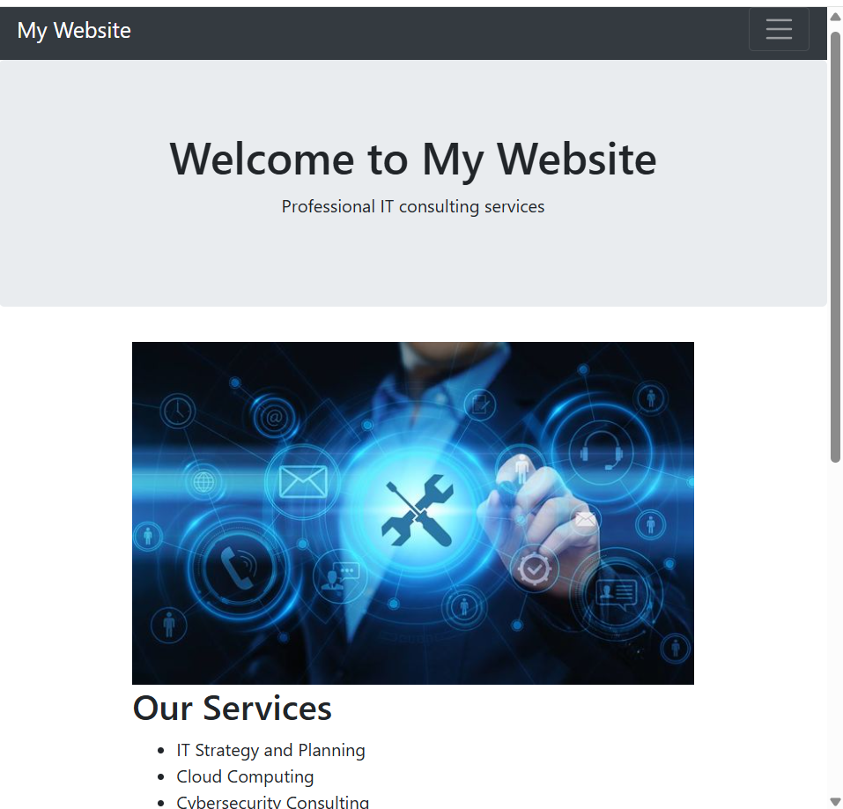

8.5 bootstrap text/typography

8.5.1 headings

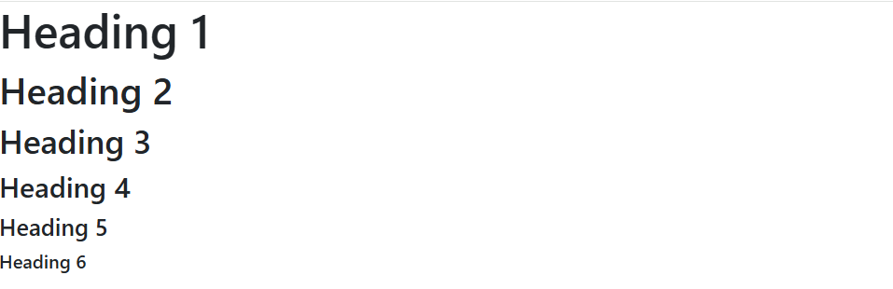

8.5.2 display headings

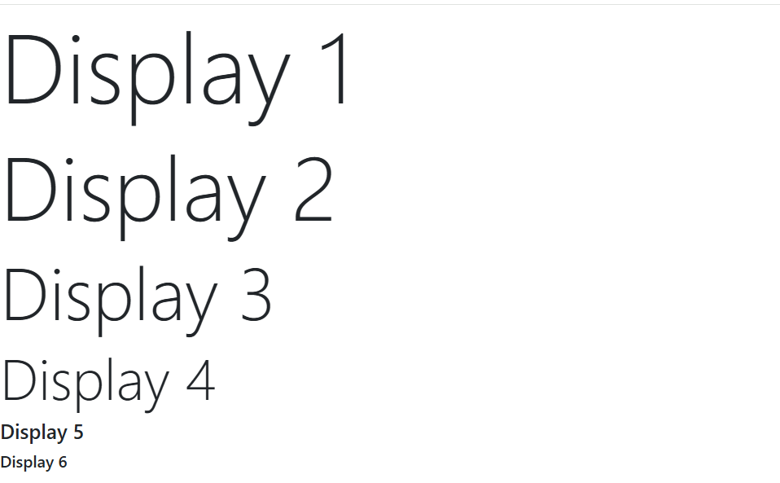

8.5.3 inline text elements

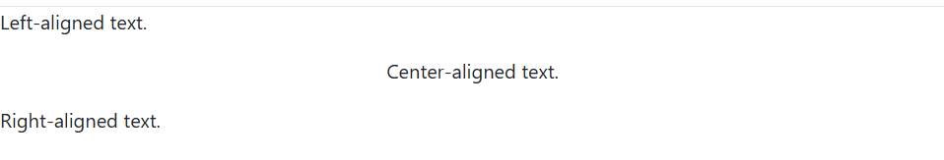

8.5.4 text color and background

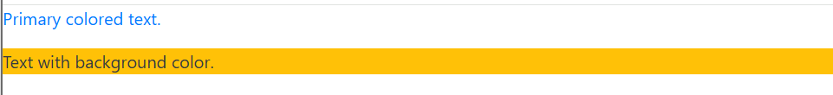

8.5.5 text wrapping and overflow

8.5.6 font size

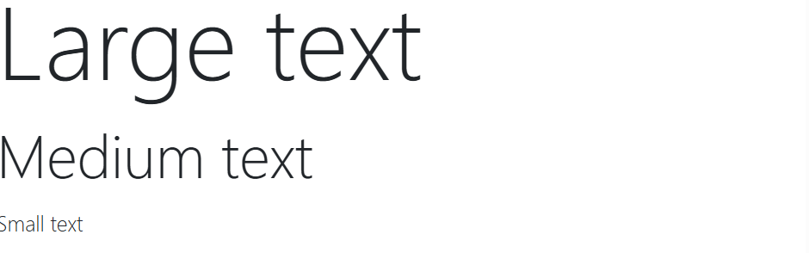

8.5.7 font weight and style



8.5.8 line height

8.5.9 lists

8.6 bootstrap CSS forms

8.6.1 basic form structure

8.6.2 form layouts

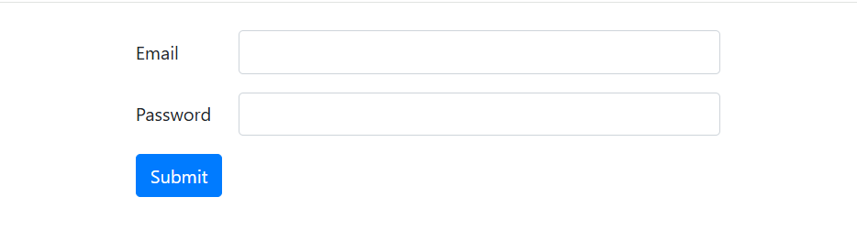

8.6.3 inline form



8.6.4 form controls

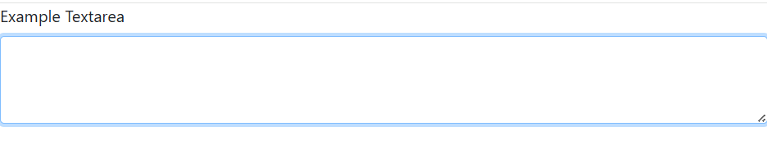

8.6.5 select menus



8.6.6 form validation

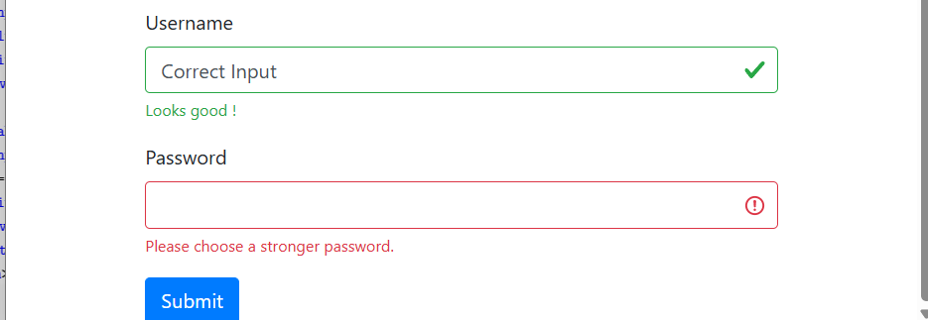

8.6.7 checkboxes and radios



8.6.8 input groups



8.6.9 floating labels

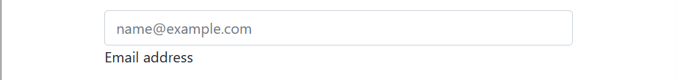

8.6.10 disable and readonly inputs

8.6.11 example form

8.7 bootstrap theme

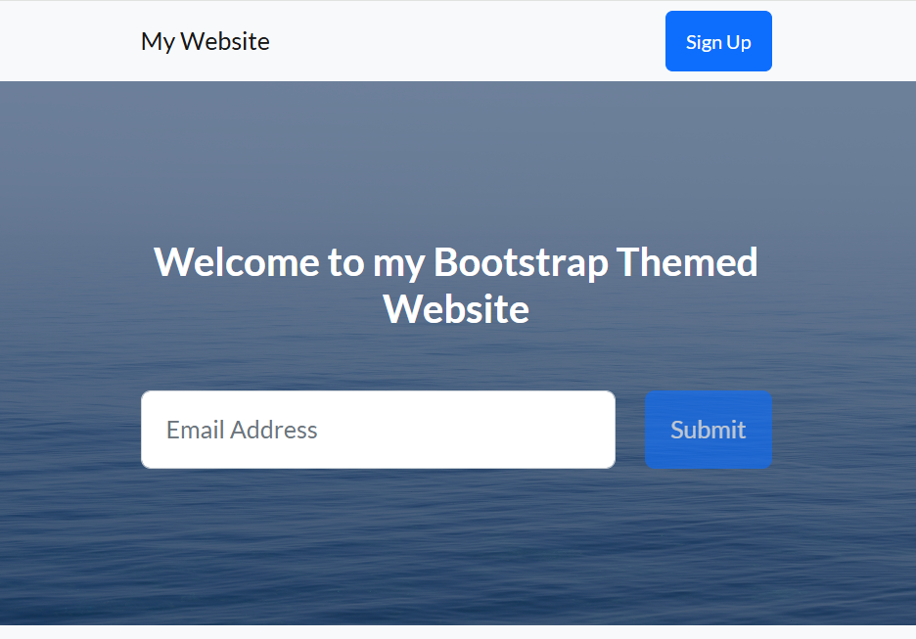

**Lab exercise**

Home.html

<!DOCTYPE html>

<html lang="en">

<head>

<meta charset="utf-8" />

<meta name="viewport" content="width=device-width, initial-scale=1, shrink-to-fit=no" />

<title>FutureTech Solutions - IT Consulting Services</title>

<meta name="description" content="FutureTech Solutions provides innovative IT consulting services for businesses." />

<meta name="author" content="FutureTech Solutions" />

<link rel="icon" type="image/x-icon" href="assets/favicon.ico" />

<!-- Google fonts-->

<link href="https://fonts.googleapis.com/css?family=Raleway:100,400,700" rel="stylesheet" />

<link href="https://fonts.googleapis.com/css?family=Lora:400,700" rel="stylesheet" />

<!-- Core theme CSS (includes Bootstrap)-->

<link href="css/styles.css" rel="stylesheet" />

<style>

.hero {

background: url('assets/img/it-hero.jpg') center center/cover no-repeat;

height: 80vh;

display: flex;

align-items: center;

justify-content: center;

color: white;

text-align: center;

}

.services .service-item {

text-align: center;

padding: 2rem;

border-radius: 10px;

transition: transform 0.3s;

}

.services .service-item:hover {

transform: translateY(-10px);

box-shadow: 0 4px 15px rgba(0,0,0,0.2);

}

</style>

</head>

<body>

<header>

<h1 class="site-heading text-center text-faded d-none d-lg-block">

<span class="site-heading-upper text-primary mb-3">Innovative IT Solutions</span>

<span class="site-heading-lower">FutureTech Solutions</span>

</h1>

</header>

<!-- Navigation-->

<nav class="navbar navbar-expand-lg navbar-dark py-lg-4" id="mainNav">

<div class="container">

<a class="navbar-brand text-uppercase fw-bold d-lg-none" href="index.html">FutureTech</a>

<button class="navbar-toggler" type="button" data-bs-toggle="collapse" data-bs-target="#navbarSupportedContent" aria-controls="navbarSupportedContent" aria-expanded="false" aria-label="Toggle navigation">

<span class="navbar-toggler-icon"></span>

</button>

<div class="collapse navbar-collapse" id="navbarSupportedContent">

<ul class="navbar-nav mx-auto">

<li class="nav-item px-lg-4"><a class="nav-link text-uppercase" href="index.html">Home</a></li>

<li class="nav-item px-lg-4"><a class="nav-link text-uppercase" href="about.html">About</a></li>

<li class="nav-item px-lg-4"><a class="nav-link text-uppercase" href="services.html">Services</a></li>

<li class="nav-item px-lg-4"><a class="nav-link text-uppercase" href="contact.html">Contact</a></li>

</ul>

</div>

</div>

</nav>

<!-- Hero Section -->

<section class="hero">

<div class="container">

<h2 class="display-4">Future-Proof IT Solutions</h2>

<p class="lead mb-4">Secure, scalable, and innovative IT services to help your business grow.</p>

<a class="btn btn-primary btn-xl" href="contact.html">Get in Touch</a>

</div>

</section>

<!-- Quick Service Highlights -->

<section class="page-section services py-5">

<div class="container">

<h2 class="text-center mb-5">Our Key Services</h2>

<div class="row g-4">

<div class="col-md-4">

<div class="service-item bg-light p-4 rounded">

<img src="assets/img/cloud-solutions.jpeg" class="img-fluid mb-3 rounded" alt="Cloud Solutions">

<h4>Cloud Solutions</h4>

<p>Seamless cloud migration with secure and scalable infrastructure for your business.</p>

</div>

</div>

<div class="col-md-4">

<div class="service-item bg-light p-4 rounded">

<img src="assets/img/cybersecurity.jpeg" class="img-fluid mb-3 rounded" alt="Cybersecurity">

<h4>Cybersecurity</h4>

<p>Protect your business from threats with advanced monitoring and data privacy solutions.</p>

</div>

</div>

<div class="col-md-4">

<div class="service-item bg-light p-4 rounded">

<img src="assets/img/it-consulting.jpg" class="img-fluid mb-3 rounded" alt="IT Consulting">

<h4>IT Consulting</h4>

<p>Expert guidance to optimize operations, improve efficiency, and drive business growth.</p>

</div>

</div>

</div>

</div>

</section>

<!-- CTA Section -->

<section class="page-section cta py-5">

<div class="container">

<div class="row">

<div class="col-xl-9 mx-auto">

<div class="cta-inner bg-faded text-center rounded p-5">

<h2 class="section-heading mb-4">

<span class="section-heading-upper">Our Commitment</span>

<span class="section-heading-lower">To Your Success</span>

</h2>

<p class="mb-0">We deliver innovative IT solutions, expert guidance, and exceptional support. Your growth and security are our top priorities.</p>

</div>

</div>

</div>

</div>

</section>

<!-- Footer -->

<footer class="footer text-faded text-center py-5">

<div class="container"><p class="m-0 small">&copy; 2025 FutureTech Solutions</p></div>

</footer>

<!-- Bootstrap core JS-->

<script src="https://cdn.jsdelivr.net/npm/bootstrap@5.2.3/dist/js/bootstrap.bundle.min.js"></script>

<!-- Core theme JS-->

<script src="js/scripts.js"></script>

</body>

</html>

About.html

<!DOCTYPE html>

<html lang="en">

<head>

<meta charset="utf-8" />

<meta name="viewport" content="width=device-width, initial-scale=1, shrink-to-fit=no" />

<title>FutureTech Solutions - About Us</title>

<meta name="description" content="Learn more about FutureTech Solutions and our IT consulting expertise." />

<meta name="author" content="FutureTech Solutions" />

<link rel="icon" type="image/x-icon" href="assets/favicon.ico" />

<link href="https://fonts.googleapis.com/css?family=Raleway:100,100i,200,200i,300,300i,400,400i,500,500i,600,600i,700,700i,800,800i,900,900i" rel="stylesheet" />

<link href="https://fonts.googleapis.com/css?family=Lora:400,400i,700,700i" rel="stylesheet" />

<link href="css/styles.css" rel="stylesheet" />

</head>

<body>

<header>

<h1 class="site-heading text-center text-faded d-none d-lg-block">

<span class="site-heading-upper text-primary mb-3">Innovative IT Solutions</span>

<span class="site-heading-lower">FutureTech Solutions</span>

</h1>

</header>

<!-- Navigation -->

<nav class="navbar navbar-expand-lg navbar-dark py-lg-4" id="mainNav">

<div class="container">

<a class="navbar-brand text-uppercase fw-bold d-lg-none" href="index.html">FutureTech Solutions</a>

<button class="navbar-toggler" type="button" data-bs-toggle="collapse" data-bs-target="#navbarSupportedContent"

aria-controls="navbarSupportedContent" aria-expanded="false" aria-label="Toggle navigation">

<span class="navbar-toggler-icon"></span>

</button>

<div class="collapse navbar-collapse" id="navbarSupportedContent">

<ul class="navbar-nav mx-auto">

<li class="nav-item px-lg-4"><a class="nav-link text-uppercase" href="index.html">Home</a></li>

<li class="nav-item px-lg-4"><a class="nav-link text-uppercase" href="about.html">About</a></li>

<li class="nav-item px-lg-4"><a class="nav-link text-uppercase" href="services.html">Services</a></li>

<li class="nav-item px-lg-4"><a class="nav-link text-uppercase" href="contact.html">Contact</a></li>

</ul>

</div>

</div>

</nav>

<!-- About Section -->

<section class="page-section about-heading">

<div class="container">

<img class="img-fluid rounded about-heading-img mb-3 mb-lg-0" src="assets/img/about-it.jpeg" alt="FutureTech Team" />

<div class="about-heading-content">

<div class="row">

<div class="col-xl-9 col-lg-10 mx-auto">

<div class="bg-faded rounded p-5">

<h2 class="section-heading mb-4">

<span class="section-heading-upper">Expertise & Innovation</span>

<span class="section-heading-lower">About FutureTech Solutions</span>

</h2>

<p>Founded in 2025, FutureTech Solutions provides professional IT consulting services tailored to businesses of all sizes. Our mission is to deliver secure, innovative, and efficient technology solutions to drive growth and success for our clients.</p>

<p class="mb-0">

Our team specializes in cloud migration, cybersecurity, and IT optimization. We partner with your business to implement solutions that enhance productivity, secure data, and support long-term growth.

</p>

</div>

</div>

</div>

</div>

</div>

</section>

<footer class="footer text-faded text-center py-5">

<div class="container"><p class="m-0 small">Copyright &copy; FutureTech Solutions 2025</p></div>

</footer>

<script src="https://cdn.jsdelivr.net/npm/bootstrap@5.2.3/dist/js/bootstrap.bundle.min.js"></script>

<script src="js/scripts.js"></script>

</body>

</html>

Services.html

<!DOCTYPE html>

<html lang="en">

<head>

<meta charset="utf-8" />

<meta name="viewport" content="width=device-width, initial-scale=1, shrink-to-fit=no" />

<title>FutureTech Solutions - IT Consulting Services</title>

<meta name="description" content="FutureTech Solutions provides innovative IT consulting services for businesses." />

<meta name="author" content="FutureTech Solutions" />

<link rel="icon" type="image/x-icon" href="assets/favicon.ico" />

<!-- Google fonts-->

<link href="https://fonts.googleapis.com/css?family=Raleway:100,100i,200,200i,300,300i,400,400i,500,500i,600,600i,700,700i,800,800i,900,900i" rel="stylesheet" />

<link href="https://fonts.googleapis.com/css?family=Lora:400,400i,700,700i" rel="stylesheet" />

<!-- Core theme CSS (includes Bootstrap)-->

<link href="css/styles.css" rel="stylesheet" />

</head>

<body>

<header>

<h1 class="site-heading text-center text-faded d-none d-lg-block">

<span class="site-heading-upper text-primary mb-3">Innovative IT Solutions</span>

<span class="site-heading-lower">FutureTech Solutions</span>

</h1>

</header>

<!-- Navigation -->

<nav class="navbar navbar-expand-lg navbar-dark py-lg-4" id="mainNav">

<div class="container">

<a class="navbar-brand text-uppercase fw-bold d-lg-none" href="index.html">FutureTech</a>

<button class="navbar-toggler" type="button" data-bs-toggle="collapse" data-bs-target="#navbarSupportedContent">

<span class="navbar-toggler-icon"></span>

</button>

<div class="collapse navbar-collapse" id="navbarSupportedContent">

<ul class="navbar-nav mx-auto">

<li class="nav-item px-lg-4"><a class="nav-link text-uppercase" href="index.html">Home</a></li>

<li class="nav-item px-lg-4"><a class="nav-link text-uppercase" href="about.html">About</a></li>

<li class="nav-item px-lg-4"><a class="nav-link text-uppercase" href="services.html">Services</a></li>

<li class="nav-item px-lg-4"><a class="nav-link text-uppercase" href="contact.html">Contact</a></li>

</ul>

</div>

</div>

</nav>

<!-- Services Section -->

<section class="page-section">

<div class="container">

<!-- Cloud Solutions -->

<div class="product-item">

<div class="product-item-title d-flex">

<div class="bg-faded p-5 d-flex ms-auto rounded">

<h2 class="section-heading mb-0">

<span class="section-heading-upper">Cloud Solutions</span>

<span class="section-heading-lower">Secure & Scalable</span>

</h2>

</div>

</div>

<img class="product-item-img mx-auto d-flex rounded img-fluid mb-3 mb-lg-0" src="assets/img/cloud-solutions.jpeg" alt="Cloud Solutions" />

<div class="product-item-description d-flex me-auto">

<div class="bg-faded p-5 rounded">

<p class="mb-0">We help businesses migrate to the cloud efficiently, ensuring security, scalability, and seamless integration with existing systems.</p>

</div>

</div>

</div>

<section class="page-section">

<div class="container">

<!-- Cybersecurity -->

<div class="product-item">

<div class="product-item-title d-flex">

<div class="bg-faded p-5 d-flex me-auto rounded">

<h2 class="section-heading mb-0">

<span class="section-heading-upper">Cybersecurity</span>

<span class="section-heading-lower">Protect Your Business</span>

</h2>

</div>

</div>

<img class="product-item-img mx-auto d-flex rounded img-fluid mb-3 mb-lg-0" src="assets/img/cybersecurity.jpeg" alt="Cybersecurity" />

<div class="product-item-description d-flex ms-auto">

<div class="bg-faded p-5 rounded">

<p class="mb-0">Our cybersecurity experts protect your business from threats, ensure data privacy, and implement advanced monitoring solutions.</p>

</div>

</div>

</div>

<section class="page-section">

<div class="container">

<!-- IT Consulting -->

<div class="product-item">

<div class="product-item-title d-flex">

<div class="bg-faded p-5 d-flex ms-auto rounded">

<h2 class="section-heading mb-0">

<span class="section-heading-upper">IT Consulting</span>

<span class="section-heading-lower">Expert Guidance</span>

</h2>

</div>

</div>

<img class="product-item-img mx-auto d-flex rounded img-fluid mb-3 mb-lg-0" src="assets/img/it-consulting.jpg" alt="IT Consulting" />

<div class="product-item-description d-flex me-auto">

<div class="bg-faded p-5 rounded">

<p class="mb-0">We provide tailored IT consulting solutions to optimize your operations, improve efficiency, and drive business growth.</p>

</div>

</div>

</div>

</div>

</section>

<footer class="footer text-faded text-center py-5">

<div class="container"><p class="m-0 small">Copyright &copy; FutureTech Solutions 2025</p></div>

</footer>

<!-- Bootstrap JS -->

<script src="https://cdn.jsdelivr.net/npm/bootstrap@5.2.3/dist/js/bootstrap.bundle.min.js"></script>

<script src="js/scripts.js"></script>

</body>

</html>

Contact.html

<!DOCTYPE html>

<html lang="en">

<head>

<meta charset="utf-8" />

<meta name="viewport" content="width=device-width, initial-scale=1, shrink-to-fit=no" />

<meta name="description" content="Contact FutureTech Solutions for innovative IT consulting services." />

<meta name="author" content="FutureTech Solutions" />

<title>Contact - FutureTech Solutions</title>

<link rel="icon" type="image/x-icon" href="assets/favicon.ico" />

<!-- Google fonts-->

<link href="https://fonts.googleapis.com/css?family=Raleway:100,400,700" rel="stylesheet" />

<link href="https://fonts.googleapis.com/css?family=Lora:400,700" rel="stylesheet" />

<!-- Core theme CSS (includes Bootstrap)-->

<link href="css/styles.css" rel="stylesheet" />

</head>

<body>

<header>

<h1 class="site-heading text-center text-faded d-none d-lg-block">

<span class="site-heading-upper text-primary mb-3">Innovative IT Solutions</span>

<span class="site-heading-lower">FutureTech Solutions</span>

</h1>

</header>

<!-- Navigation-->

<nav class="navbar navbar-expand-lg navbar-dark py-lg-4" id="mainNav">

<div class="container">

<a class="navbar-brand text-uppercase fw-bold d-lg-none" href="index.html">FutureTech</a>

<button class="navbar-toggler" type="button" data-bs-toggle="collapse" data-bs-target="#navbarSupportedContent"

aria-controls="navbarSupportedContent" aria-expanded="false" aria-label="Toggle navigation">

<span class="navbar-toggler-icon"></span>

</button>

<div class="collapse navbar-collapse" id="navbarSupportedContent">

<ul class="navbar-nav mx-auto">

<li class="nav-item px-lg-4"><a class="nav-link text-uppercase" href="index.html">Home</a></li>

<li class="nav-item px-lg-4"><a class="nav-link text-uppercase" href="about.html">About</a></li>

<li class="nav-item px-lg-4"><a class="nav-link text-uppercase" href="services.html">Services</a></li>

<li class="nav-item px-lg-4"><a class="nav-link text-uppercase" href="contact.html">Contact</a></li>

</ul>

</div>

</div>

</nav>

<!-- Contact Section -->

<section class="page-section">

<div class="container">

<h2 class="text-center mb-4">Contact Us</h2>

<p class="text-center mb-5">Have a question or want to work with us? Fill out the form below and we'll get back to you promptly.</p>

<form>

<div class="mb-3">

<label for="name" class="form-label">Name</label>

<input type="text" class="form-control" id="name" placeholder="Your full name" required>

</div>

<div class="mb-3">

<label for="email" class="form-label">Email</label>

<input type="email" class="form-control" id="email" placeholder="name@example.com" required>

</div>

<div class="mb-3">

<label for="subject" class="form-label">Subject</label>

<input type="text" class="form-control" id="subject" placeholder="Subject of your message" required>

</div>

<div class="mb-3">

<label for="message" class="form-label">Message</label>

<textarea class="form-control" id="message" rows="5" placeholder="Type your message here..." required></textarea>

</div>

<div class="text-center">

<button type="submit" class="btn btn-primary btn-xl">Send Message</button>

</div>

</form>

</div>

</section>

<!-- Footer -->

<footer class="footer text-faded text-center py-5">

<div class="container"><p class="m-0 small">&copy; 2025 FutureTech Solutions</p></div>

</footer>

<!-- Bootstrap core JS-->

<script src="https://cdn.jsdelivr.net/npm/bootstrap@5.2.3/dist/js/bootstrap.bundle.min.js"></script>

<!-- Core theme JS-->

<script src="js/scripts.js"></script>

</body>

</html>

Webpage

